ServiceNow Integration

Runbook for deploying application

Copyright 2018 Nutanix, Inc.

Nutanix, Inc.

1740 Technology Drive, Suite 150

San Jose, CA 95110

All rights reserved. This product is protected by U.S. and international copyright and intellectual property laws.

Nutanix is a trademark of Nutanix, Inc. in the United States and/or other jurisdictions. All other marks and names mentioned herein may be trademarks of their respective companies.

Contents

Executive Summary 5

Introduction 6

Audience 6

Purpose 6

About Nutanix 6

Prerequisities 7

ServiceNow 7

Nutanix AHV 7

ServiceNow – Setting up the MID server 8

ServiceNow – Setting E-Mail notifications 8

ServiceNow – Populate the CMDB 8

Service Now – Configuring LDAP 9

Service Now – Environment Configuration 12

Plugins 14

Plugin activation 14

Plugin Configuration 16

Importing the ServiceNow Application 17

Nutanix Configuration Tables 18

Operating Systems 18

Cluster Types 18

Credential Types 19

Authentication Types 19

Authentication Methods 19

Authentication 20

Guest Customization Types 20

Guest Customizations 21

API Specifications 23

Credentials 24

Cluster Configurations 25

Catalog Items 25

Catalog Items Credentials 26

VM Sizes 26

Final Configurations 27

Service Catalog 27

Adjust Discovery Settings for CMDB 29

Assign Roles 29

APPENDIX A – FAQ 30

# Executive Summary

This document contains the steps to install and configure our ServiceNow integration with a Nutanix AHV Cluster and SSP.

# Introduction

## Audience

This document is intended for IT administrators and architects.

## Purpose

Our integration is contained inside a ServiceNow application, which can be imported directly from one of our Dev instances or imported as an update set XML. This document will show you how to import our application and make the necessary configuration changes to start provisioning AHV VM’s from your ServiceNow instance.

## About Nutanix

Nutanix makes infrastructure invisible, elevating IT to focus on the applications and services that power their business. The Nutanix enterprise cloud platform leverages web-scale engineering and consumer-grade design to natively converge compute, virtualization, and storage into a resilient, software-defined solution with rich machine intelligence. The result is predictable performance, cloud-like infrastructure consumption, robust security, and seamless application mobility for a broad range of enterprise applications. Learn more at [www.nutanix.com](http://www.nutanix.com) or follow up on Twitter [@nutanix](https://twitter.com/nutanix).

# Prerequisities

## ServiceNow

1. ServiceNow should be version Istanbul or higher.
2. Recommended to load and test in a development instance before pushing to a production instance
3. The ServiceNow MID server needs to be installed and already configured
4. MID server should have access to PRISM API
5. Instance should be configured with Active Directory Integration
6. Manager hierarchy should be in place to utilize approvals
7. Administrator Access to instance is required
8. CMDB Environments should be configured – Options to populate the CMDB are described in the [ServiceNow documentation](https://docs.servicenow.com/bundle/jakarta-servicenow-platform/page/product/configuration-management/concept/c_OptionsToPopulateCMDB.html)
9. E-mail Setup should be completed – for instructions on how to setup E-Mail notifications see the [ServiceNow documentation](https://docs.servicenow.com/bundle/jakarta-servicenow-platform/page/administer/reference-pages/concept/c_EmailConfiguration.html)

## Nutanix AHV

1. Requires AOS 5.5.0.4
2. Nutanix Cluster deployed and configured
3. SSP deployed and configured
4. Projects and Networks created
5. Enable IP address management with an IP address pool configured for the networks to be used.
6. Images uploaded to Prism Central   
   (verify image service has automatically uploaded to registered clusters)
7. Linux image(s) have cloud-init package installed
8. Windows Images should have been sysprep sealed  
   (sysprep /generalize /shutdown /oobe)
9. API user with admin access created

## ServiceNow – Setting up the MID server

The MID server (Management, Instrumentation, and Discovery) is a Java application that runs as a Windows service or UNIX daemon on a server in your local network. The MID Server facilitates communication and the movement of data between a ServiceNow instance and external applications, data sources, and services.

If you have no MID server running in your environment, please follow the ServiceNow documentation which can be found [here](https://docs.servicenow.com/bundle/jakarta-servicenow-platform/page/product/mid-server/concept/c_MIDServerInstallation.html).

Specific installation instructions for Windows and Linux systems:

[Install the MID server on a Linux host](https://docs.servicenow.com/bundle/jakarta-servicenow-platform/page/product/mid-server/task/t_InstallAMIDServerOnLinux.html#t_InstallAMIDServerOnLinux)

[Install the MID server on a Windows host](https://docs.servicenow.com/bundle/jakarta-servicenow-platform/page/product/mid-server/task/t_InstallAMIDServerOnWindows.html#t_InstallAMIDServerOnWindows)

After completing the MID server installation it is important to [test the MID server connection](https://docs.servicenow.com/bundle/jakarta-servicenow-platform/page/product/mid-server/task/t_ValidateNetworkConnectivity.html) to the ServiceNow instance as well as [validating the MID server](https://docs.servicenow.com/bundle/jakarta-servicenow-platform/page/product/mid-server/task/t_ValidateAMIDServer.html) to ensure that it is trusted to access credentials by the ServiceNow instance for automations.

## ServiceNow – Setting E-Mail notifications

Notifications keep users informed of events that concern them. ServiceNow can notify users by email, SMS text message, or push notification. Details on how to set up E-Mail notification can be found [here](https://docs.servicenow.com/bundle/jakarta-servicenow-platform/page/administer/reference-pages/concept/c_EmailConfiguration.html).

## ServiceNow – Populate the CMDB

The Configuration Management data base (CMDB) creates and maintains the logical configurations your network infrastructure needs to support a ServiceNow service.

You can populate the CMDB by using Discovery, by importing information from another source, by integrating with an existing external CMDB, or by manually creating a CI.

Detailed information about the Options to populate the CMDB can be found at the ServiceNow documentation following [this link](https://docs.servicenow.com/bundle/jakarta-servicenow-platform/page/product/configuration-management/concept/c_OptionsToPopulateCMDB.html).

## Service Now – Configuring LDAP

1. Navigate to **System LDAP > Create New Server**  
   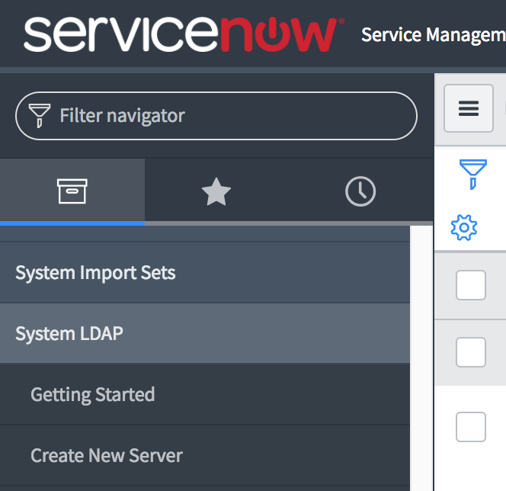
2. Enter your LDAP details in the form and click submit. You will be redirected to the newly created LDAP Server configuration page  
    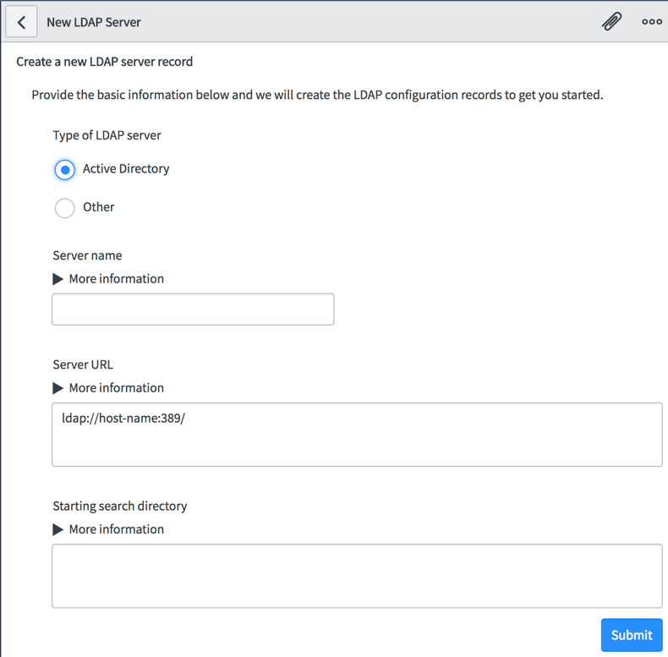
3. Before making changes to the LDAP configuration, make sure you scroll down to the **Related Links** section and select **Stop Listener**  
   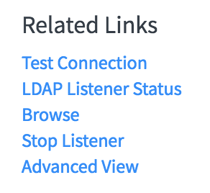
4. Once the page has refreshed, enter your LDAP details like login name and password, as well as the search directory string. Specify your MID server in this step as well.  
   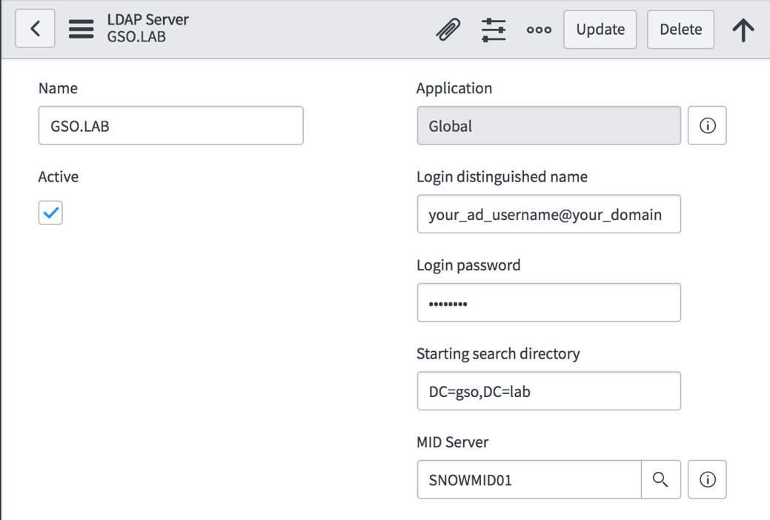
5. Scroll down the the **Related Links** section again and select **Test Connection**
6. If the connection test was successful make sure to start the Listener again via **Related Links > Start Listener**
7. Navigate to **System LDAP > Scheduled Loads**  
   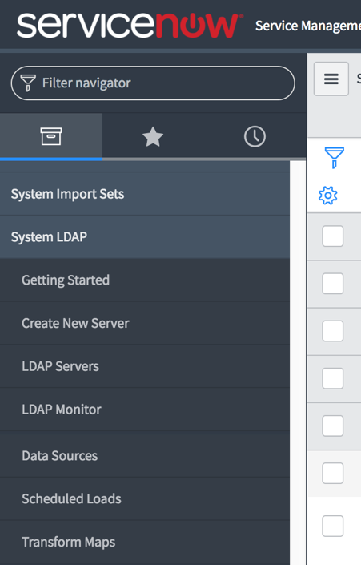
8. In the table, select your DOMAIN/Users Import.  
   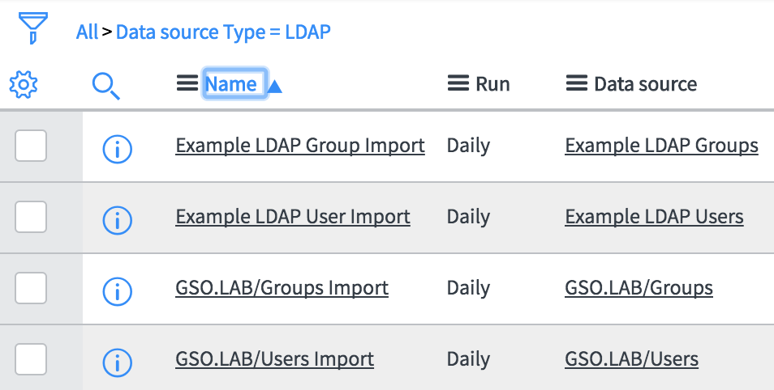
9. On the next screen select Execute Now to run the User Import immediately without waiting for the next scheduled load.  
   
10. Repeat step 8 and 9 for the Group Import

## Service Now – Environment Configuration

If you have not yet set up your environment or standing up a new developer instance, please follow these steps to configure your environment.

1. Navigate to **System Definition > Tables**  
   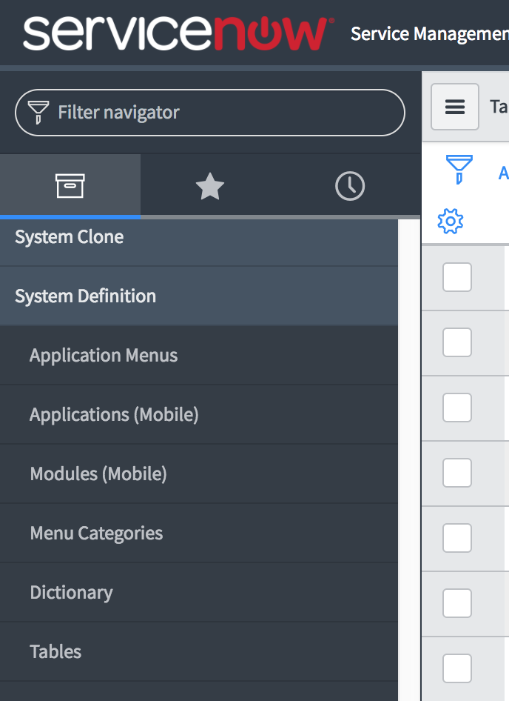
2. In the top menu search for **cmdb_ci_environment**  
   (make sure you’re searching for Name and not Label)  
   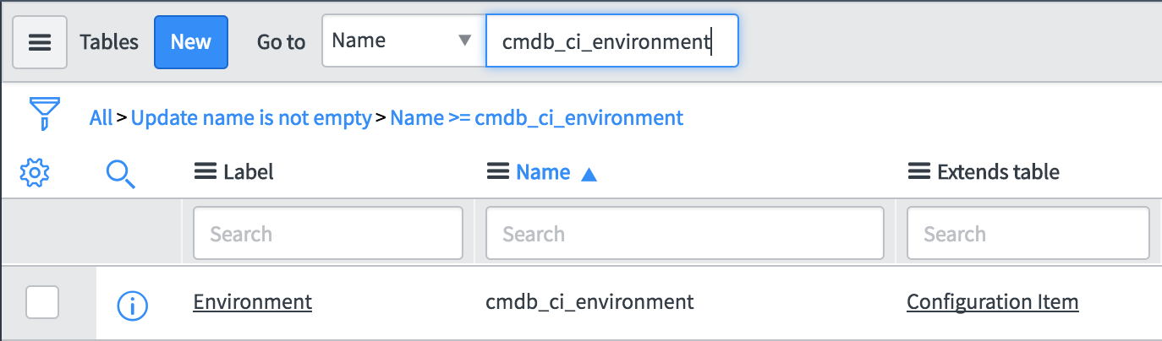
3. Select **Environment** from the returned search results
4. Scroll down to the **Related Links** section and select **Show List**  
   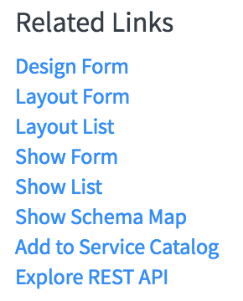
5. Click **New** at the top menu and create your environment  
   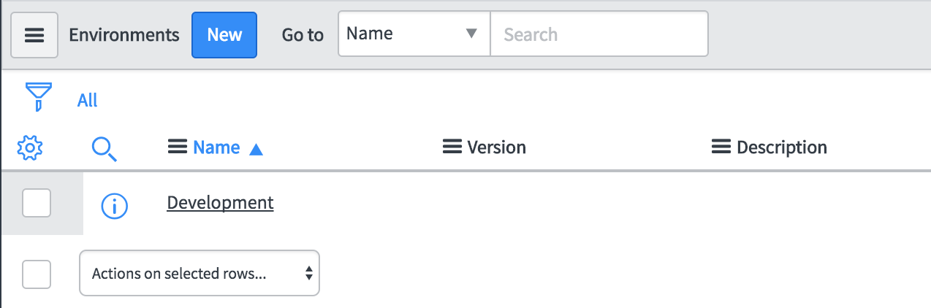
6. Fill out the details and **Submit** the changes  
   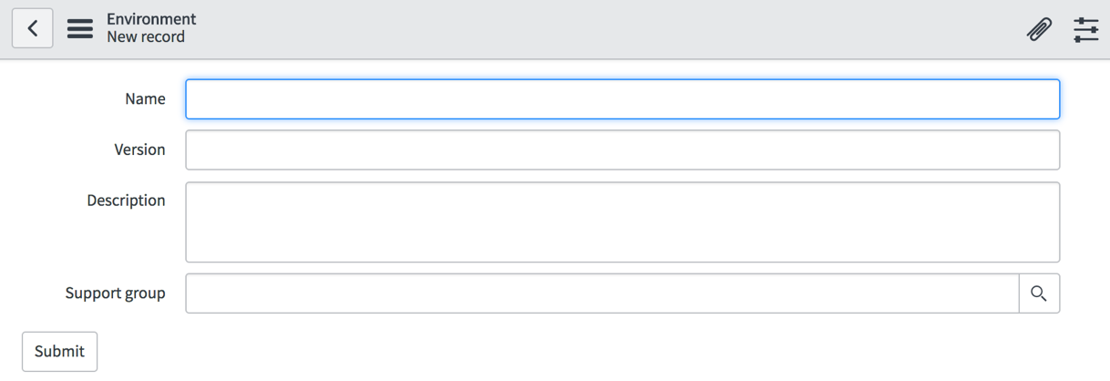

# Plugins

## Plugin activation

1. Navigate to **System Definitions > Plugins**  
   
2. In the search box enter the substring of the plugin name to be searched for
   1. In this example we are using **encrypt** to search for the **Encryption Support** plugin  
      
3. Right click on the plugin and select **Activate/Upgrade**  
     
   
4. Once complete the list will refresh and the plugin status will change from Inactive to Active
5. Repeat steps 1 through 4 for the following list of plugins that need to be activated
   1. Encryption Support
   2. Configuration Management for Scoped Apps (CMDB)
   3. Performance Analytics – Content Pack – Discovery
   4. Performance Analytics – Content Pack – Configuration Management (CMDB)

## Plugin Configuration

To configure the Discovery Plugin, navigate to the **Discovery** > **Credentials** module  
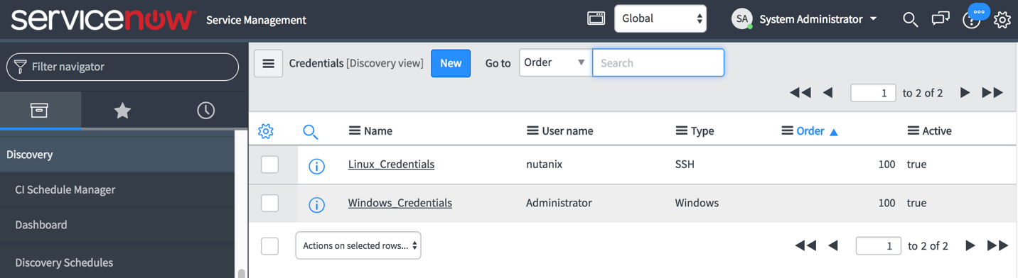

1. Click **New** on the Credentials list
2. Enter the required credentials for Linux and/or Windows access

# Importing the ServiceNow Application

This section describes how to Import the Completed Update Set from XML.

1. On the target instance, navigate to **System Update Sets > Retrieved Update Sets**
2. Under Related Links, choose **Import Update Set from XML**
3. Choose XML file provided by Nutanix Services for the **NutanixSSP Utilities** and click **Upload**
4. Once uploaded click on **NutanixSSP Utilities** and then click **Preview Update Set**  
   The file you are looking for is called ‘ServiceNow_NutanixSSP-Utilities.xml’
   1. There should not be any errors
   2. Click **Commit Update Set**
5. Go back to Related Links, choose **Import Update Set from XML** and perform the same steps for the **NutanixSSP** XML import.  
   The file you are looking for is called ‘ServiceNow_NutanixSSP-Core.xml’
6. After Update Set **NutanixSSP** is loaded, click Click on **NutanixSSP** to bring up the Retrieved Update Set
7. Click on **Preview Update Set**
   1. There should not be any errors
      1. If there are any errors, there should only be a couple (between 7 to 9). Skip those errors by selecting them at the bottom of the page and running **Skip** from the drop-down menu.
      2. If you find that you are missing tables such as ldap_import, please verify that the LDAP server configuration is correct and that you have run the group and user imports under **System LDAP > Scheduled Loads**.
   2. Click **Commit Update Set**

# Nutanix Configuration Tables

There are several tables that will need to have new records created. The procedure to insert new records into the tables is as follows:

1. Navigate to **Nutanix SSP > Module** (This will be the table to insert new records into).
2. Select **New**
3. Enter the information as recorded below.
4. Click **Submit**

**Please enter records into the following tables in the following order. (Table modules are in the appropriate order on the NutanixSSP menu)**

**Note: Types are required to be entered exactly as below. Operating Systems, Customization Specs, Credentials, Cluster Configurations and Catalog Items are tailored to match environment. Records listed below for these tables are examples of how the records are entered.**

## Operating Systems

Enter the OS information as follows:

|  |  |  |
| --- | --- | --- |
| OS | Price | Recurring Price |
| Windows |  | 50.00 |
| Linux |  |  |

## Cluster Types

Enter the following type into the table:

* Default

Additional types can and should be entered based on customer input. Examples of types can be: SQL, Oracle, All Flash, Tier-1, Tier-2 and so on.

## Credential Types

Enter the following types into the table:

* Windows Admin
* Linux Admin
* Nutanix Cluster
* Domain Join
* Windows Auto Logon

## Authentication Types

Enter the authentication types as follows:

|  |  |
| --- | --- |
| Type | User Label |
| SSH | Login |
| Login | User |
| HTTP | User Name |

## Authentication Methods

Enter the authentication methods as follows:

|  |  |  |  |
| --- | --- | --- | --- |
| Method | Hidden | Password Label | Form Field |
| Password | Unchecked | Password |  |
| Basic Auth | Unchecked | Password |  |
| Token | Unchecked | Token |  |
| Publickey | Checked | SSH Key Passphrase | ssh_private_key |

## Authentication

Enter the authentication records as follows:

|  |  |  |
| --- | --- | --- |
| Authentication Name | Authentication Types | Authentication Methods |
| Basic Auth | HTTP | Basic Auth |
| SSH Key | SSH | Publickey |
| Token | HTTP | Token |
| Default Login | Login | Password |
| SSH Login | SSH | Password |

## Guest Customization Types

Add the following customization types as follows:

|  |  |
| --- | --- |
| Name | Description |
| cloud_init | Linux Customization Type |
| sysprep | Windows Customization Type |

## Guest Customizations

Enter the cloud-init or unattend.xml data into this table. Demo data is as follows:

Note: Specs are to be customized per environment, OS and server deployment required. The specs included below are strictly listed as examples. The product keys and private keys have been altered and are not usable.

|  |  |  |  |
| --- | --- | --- | --- |
| Name | Type | Description | Spec |
| Cloud-Init | cloud_init | Generic Cloud-Init | #cloud-config  fqdn: ${vm_name}  manage_etc_hosts: true |
| Server 2012R2  or Server 2016 | sysprep | Windows Server 2012R2 or 2016 with minor customizations | **(BELOW IS AN EXAMPLE)**  <?xml version="1.0" encoding="utf-8"?>  <unattend xmlns="urn:schemas-microsoft-com:unattend">  <settings pass="oobeSystem">  <component name="Microsoft-Windows-Shell-Setup" processorArchitecture="amd64" publicKeyToken="<public token goes here>" language="neutral" versionScope="nonSxS" xmlns:wcm="http://schemas.microsoft.com/WMIConfig/2002/State" xmlns:xsi="http://www.w3.org/2001/XMLSchema-instance">  <OOBE>  <HideEULAPage>true</HideEULAPage>  </OOBE>  <UserAccounts>  <AdministratorPassword>  <Value>${windows_admin_password}</Value>  <PlainText>true</PlainText>  </AdministratorPassword>  </UserAccounts>  </component>  <component name="Microsoft-Windows-International-Core" processorArchitecture="amd64" publicKeyToken="public token goes here" language="neutral" versionScope="nonSxS" xmlns:wcm="http://schemas.microsoft.com/WMIConfig/2002/State" xmlns:xsi="http://www.w3.org/2001/XMLSchema-instance">  <InputLocale>en-US</InputLocale>  <SystemLocale>en-US</SystemLocale>  <UILanguage>en-US</UILanguage>  <UserLocale>en-US</UserLocale>  </component>  </settings>  <settings pass="specialize">  <component name="Microsoft-Windows-Shell-Setup" processorArchitecture="amd64" publicKeyToken="="<public token goes here>" language="neutral" versionScope="nonSxS" xmlns:wcm="http://schemas.microsoft.com/WMIConfig/2002/State" xmlns:xsi="http://www.w3.org/2001/XMLSchema-instance">  <ComputerName>${vm_name}</ComputerName>  <RegisteredOrganization>”Org goes here”</RegisteredOrganization>  <RegisteredOwner>="owner goes here”</RegisteredOwner>  <TimeZone>Pacific Standard Time</TimeZone>  <ProductKey>XXXXX-XXXXX-XXXXX-YYYYY-ZZZZZ</ProductKey>  </component>  <component name="Microsoft-Windows-UnattendedJoin" processorArchitecture="amd64" publicKeyToken="="public token goes here"  language="neutral" versionScope="nonSxS" xmlns:wcm="http://schemas.microsoft.com/WMIConfig/2002/State"  xmlns:xsi="http://www.w3.org/2001/XMLSchema-instance">  <Identification>  <UnsecureJoin>false</UnsecureJoin>  <Credentials>  <Domain>”Domain goes here”</Domain>  <Password>${domain_user_password}</Password>  <Username>${domain_user}</Username>  </Credentials>  <JoinDomain>”Domain goes here“</JoinDomain>  </Identification>  </component>  </settings>  </unattend> |

## API Specifications

Enter the API Spec for a intentful VM build. Provided is an example for a single disk Linux VM. Please reference developer.nutanix.com v3 API guide for guidelines on what is available for VM intentful Spec.

The following parameters are available and updated by default upon VM request:

* vm_name
* vm_num_vcpus
* vm_memory_mb
* vm_network_uuid
* project_uuid
* vm_user

|  |  |  |
| --- | --- | --- |
| Name | Description | Spec |
| linux1disk | API Spec for Single Disk VM - 60GB | {"spec":{"name":"${vm_name}","resources":{"power_state":"ON","num_vcpus_per_socket":1,"num_sockets":${vm_num_vcpus},"memory_size_mib":${vm_memory_mb},"power_state_mechanism":{"mechanism":"HARD"},"disk_list":[{"disk_size_mib":61440,"device_properties":{"device_type":"DISK","disk_address":{"adapter_type":"SCSI","device_index":0}},"data_source_reference":{"kind":"image","uuid":""}}],"guest_customization":{"cloud_init":{"user_data":""}},"nic_list":[{"subnet_reference":{"uuid":"${vm_network_uuid}","kind":"subnet"}}]}},"metadata":{"project_reference":{"uuid":"${project_uuid}","kind":"project"},"kind":"vm","owner_reference":{"kind":"user","uuid":"${vm_user}"},"categories":{}},"api_version":"3.0.0"} |
| windows1disk | API Spec for Single Disk VM – 50GB | {"spec":{"name":"${vm_name}","resources":{"power_state":"ON","num_vcpus_per_socket":1,"num_sockets":${vm_num_vcpus},"memory_size_mib":${vm_memory_mb},"power_state_mechanism":{"mechanism":"HARD"},"disk_list":[{"disk_size_mib":50000,"device_properties":{"device_type":"DISK","disk_address":{"adapter_type":"SCSI","device_index":0}},"data_source_reference":{"kind":"image","uuid":""}}],"guest_customization":{"sysprep":{"unattend_xml":""}},"nic_list":[{"subnet_reference":{"uuid":"${vm_network_uuid}","kind":"subnet"}}]}},"metadata":{"project_reference":{"uuid":"${project_uuid}","kind":"project"},"kind":"vm","owner_reference":{"kind":"user","uuid":"${vm_user}"},"categories":{}},"api_version":"3.0.0"} |
|  |  |  |

## Credentials

Enter the credential records as follows:

|  |  |  |  |  |  |  |  |
| --- | --- | --- | --- | --- | --- | --- | --- |
| Name | Credential Type | User | Password | Authentication | SSH Private Key  (Hidden unless SSH Key is selected for Authentication) | User Variable Name | Password Variable Name |
| Enter cluster name here | Nutanix Cluster | Enter cluster user account for access here | Enter password for user | Basic Auth |  | nutanix_cluster_user | nutanix_cluster_password |
| Enter Domain name ere | Domain Join | Enter User name with access to join Windows servers to the Domain | Enter domain user password | Default Login |  | domain_user | domain_user_password |
| Enter Name for Linux account | Linux Admin | Enter Linux Admin user name here | Enter password for linux admin here | SSH Login |  | linux_admin_user | linux_admin_password |
| Windows Admin | Windows Admin | administrator | Enter adimistrator password here | Default Login |  | windows_admin_user | windows_admin_password |
| Windows Adminstrator Auto Logon Account | Windows Auto Logon | administrator | Enter Auto logon account password here | Default Login |  | windows_auto_logon_user | windows_auto_logon_password |

## Cluster Configurations

Enter the credential records as follows for your Prism Central instance

|  |  |  |  |  |  |  |  |  |
| --- | --- | --- | --- | --- | --- | --- | --- | --- |
| Name | FQDN | IP | Uuid | Environment | Type | Location | Credentials | Description |
| PC 5.5 name is entered here | PC 5.5 FQDN is entered here | PC 5.5 IP is entered here | not needed | Select Environment  (this is pulled from the CMDB environment entries) | Default | Select Location  (This is pulled from the Location table for the ServiceNow instance. | Select the cluster credentials that were setup in the previous step | Enter a description |

## Catalog Items

Create an entry for each disk image you would like for your catalog. To get the Disk Image UUID, follow these instructions:

* SSH to Prism Element and login with nutanix
* type acli image.list
* This will show all images and their UUID

|  |  |  |  |  |  |  |
| --- | --- | --- | --- | --- | --- | --- |
| Name | UUID | OS Type | Cluster Name | Description | API Specification | Customization Spec |
| Enter a name for the Catalog Item here | Disk Image UUID is entered here | Select the appropriate OS type | Select the cluster that the template resides on | Enter a description here | Select the appropriate API specification. | Select the appropriate customization spec. |
|  |  |  |  |  |  |  |

## Catalog Items Credentials

Enter the catalog item and credential information as follows:

|  |  |
| --- | --- |
| Catalog Item | Credential |
| Catalog item to link with credential  e.g. Below | Credential to link with catalog item  e.g. Below |
| Windows Server 2012R2 | **Name** of **Windows Admin** type |
| Windows Server 2012R2 | **Name** of **Domain Join** type |
| Windows Server 2012R2 | **Name** of **Windows Auto Logon** type |

## VM Sizes

To enable t-shirt sizing of your catalog items, fill out the following table:

|  |  |  |  |  |  |
| --- | --- | --- | --- | --- | --- |
| Size | Number CPU | Memory in MB | Price | Recurring Price | Description |
| Enter Size  (small,large,etc) | Enter Number of CPU Sockets | Enter Memory in MB | Enter Price for this size |  |  |

# Final Configurations

## Service Catalog

1. Navigate to **Self Service > Service Catalog**   
     
   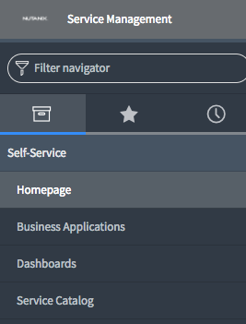
2. Select the **+ sign** at the top right of the Service Catalog view
3. Add **Nutanix Services** to the desired position of your Service Catalog  
     
   

## Adjust Discovery Settings for CMDB

1. As a System Administrator, go to **Discovery Definition > Probes**
2. Make sure you are in the **Global Context**, not the NutanixSSP before proceeding
3. Search for Probe Name **Shazzam**
4. Click on **Shazzam** in results to edit
5. Add or modify the following probe parameter: **BannerTCP_waitForConnectMS** with a value of **120000**

## Assign Roles

Assign additional roles to the user or group that will be requesting items via the catalog.

1. Navigate to User **Administrator > Users (or Groups)** and select the correct user or group you want to modify.
2. At the bottom of the page select the **Edit…** button within the **Roles** table
3. Assign the following roles:
   1. x_72900_nutanixssp_ssp_users_user
   2. x_72900_nutanixssp.security_context_user
   3. x_72900_nutanixssp.operating_systems_user
   4. x_72900_nutanixssp.cluster_configurations_user
   5. x_72900_nutanixssp.vm_sizes_user

# APPENDIX A – FAQ

## ServiceNow Development Instance modifications

When working in a ServiceNow development instance, make sure you remove the instance demo data before starting to work on the instance. To remove the demo data, **login to your ServiceNow developer account** and navigate to **Manage > My Instance**. Make sure you select the **correct instance** and then go to **Action > Remove demo data**.

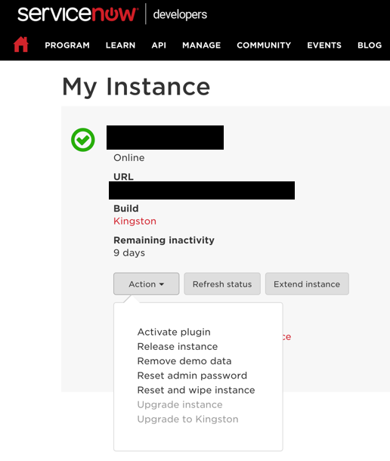



## Service Catalog (optional step if Nutanix Services is not showing in the Self-Service section)

1. Add catalog item **Nutanix Services** to your service catalog
2. Navigate to **System Applications > Studio**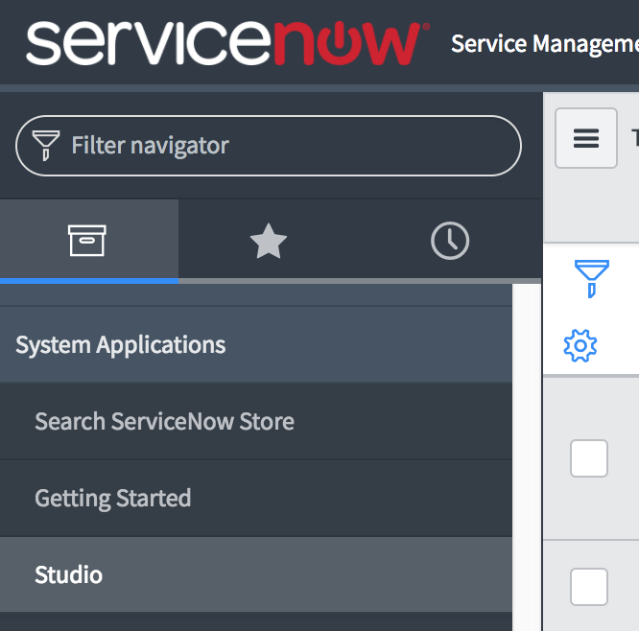
3. You will be presented with the **Load Application** view, select **NutanixSSPv5**  
   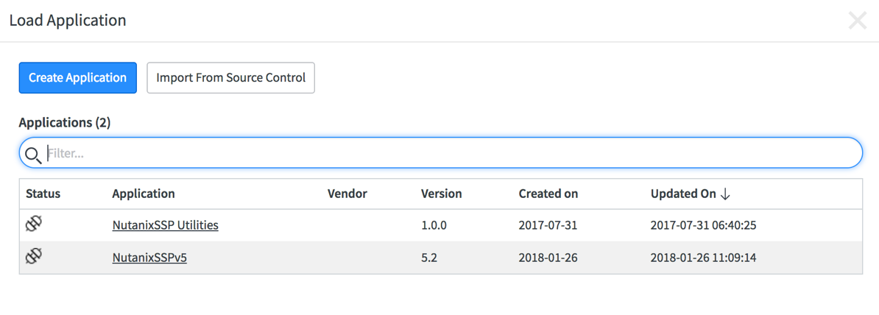
4. Within the Studio Editor navigate to   
   **Service Catalog > Catalog Items> AHV Choose OS**
5. In the Catalog Item view, select the appropriate Catalog for your environment  
   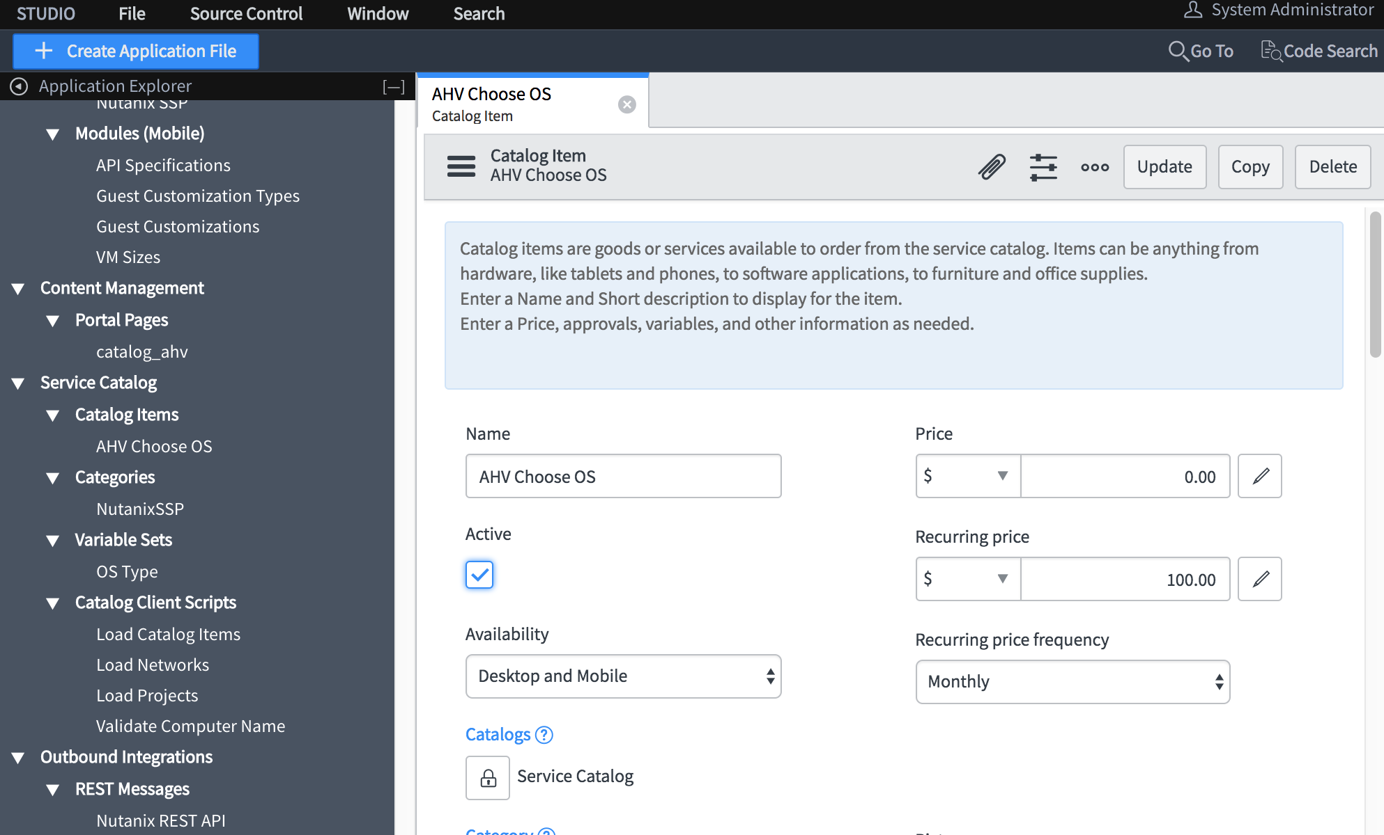
6. Login with your user or use the **Impersonate User** function by selecting the **System Administrator** account at the top right of the ServiceNow screen
7. Navigate to **Service Catalog** and you’ll be presented with your Service Catalog items which should now include **AHV Choose OS**  
   **Note:** if **AHV Choose OS** is not showing up, try using the **search function** at the top right of the **Service Catalog** screen.